

Bank Management System

This Photo by Unknown author is licensed under CC BY-SA.



**Sachin Yadav**

**Our Team Infographics**

19001003108

19001003106

**Sahil**

**Sharmaa**

**Our Team Infographics**

**Dr.**

**Shruti**

**Dr.**

**Parul**

**Tomar**

**Mentor**

**Project**

**Coordinator**

through PC or laptop.

**Objective**

❖

The “Bank Management System”

project is a model Internet Banking

Site.

❖

This site enables the customers to

perform the basic banking transactions

by sitting at their office or at homes

❖

The system provides the access to the

customer to create an account,

deposit/withdraw the cash from his

account, also to view reports of all

accounts present.

❖

 The customers can access the banks

website for viewing their Account

details and perform the transactions

on account as per their requirements



Topics

Covered

Learned Python

Learned Tkinter for GUI

Learning SQL and Sqlite3 for

Database

Created Admin Panel

-->

Created Customer Panel

-->

--> Created Home Window

**Work Done Till Date**

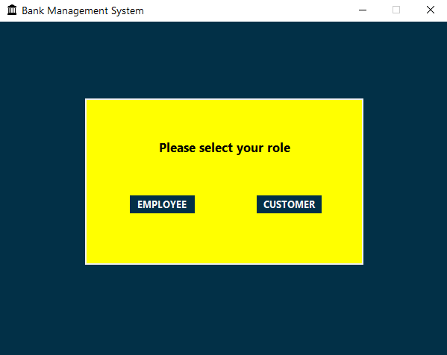

ScreenShots

**Home Screen**

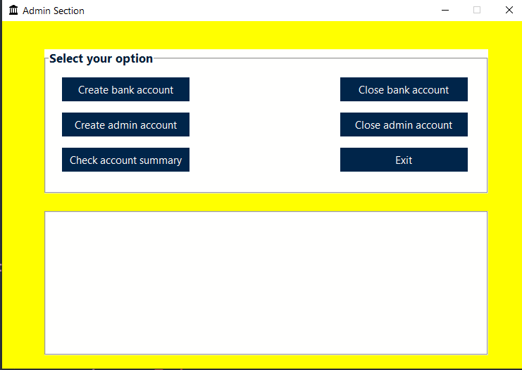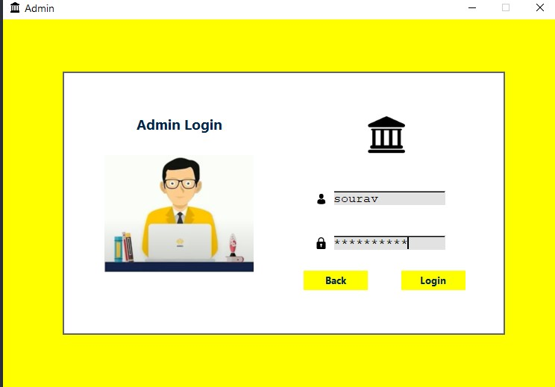

ScreenShots

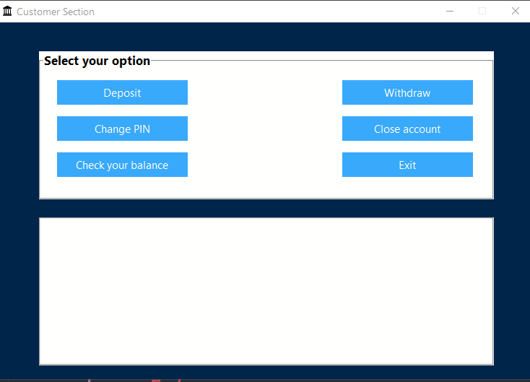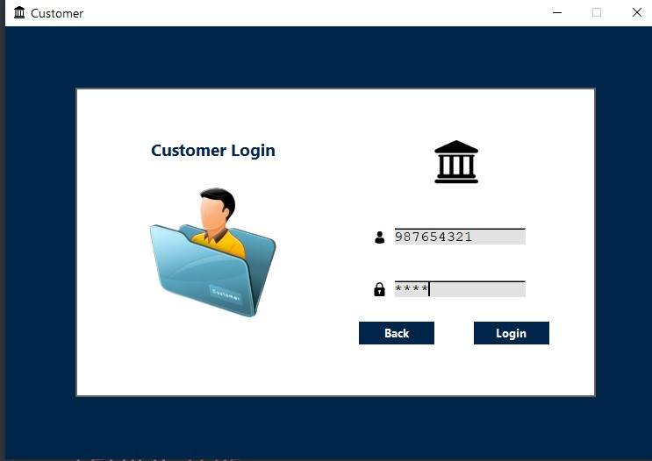

ScreenShots

ScreenShots



ScreenShots